

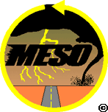

The northeast quadrant of the United States generally has fairly tame weather. Severe weather events may well be described as "infrequent": infrequent hurricanes, infrequent tornadoes, infrequent derechoes, and infrequent thunderstorms. However, one severe weather event that can be depended on to occur with uncanny regularity is the Nor'easter.

The primary difference between Nor’easters and hurricanes is that hurricanes form in the tropics and have warm cores. Extratropical storms form in the middle latitudes and have cold cores (meaning that their strongest winds are NOT near the surface and NOT concentrated near the center of the Low). Extratropical storms can be larger, sometimes over 1,000 miles across, and usually pass slowly. Minimum winds associated with a hurricane are 65 knots, and the winds associated with an extratropical storm seldom exceed 50 knots.

Nor'easters, named for the strong northeasterly winds blowing in ahead of the storm, are also referred to as extratropical cyclones, mid-latitude storms, or Great Lake storms. Mid-latitude cyclones are characterized by having a Low Pressure system with associated warm, cold, and occluded fronts. Nor’easters are a type of mid-latitude cyclone that occur off the U.S. east coast. They can occur at any time of the year, but the ones that occur during the fall and winter months are usually the most violent because of the temperature differences of the converging air masses: the cold air is colder, and the warm air drawn up from the south and from the ocean is still quite warm. They usually develop between 30-35N, as that’s where the Gulf Stream comes closest to the continent.

Most Nor'easters start from a low-pressure system that forms in the south, most often the Gulf of Mexico, and is drawn across to the northeast by the jet stream. The divergence or diffluence in the upper atmosphere caused by the jet removes and disburses the rising air at a faster rate than it is replaced at the surface, which along with the Coriolis Effect, creates and develops the cyclone, or Low. Their northeast track brings them up along the east coast past the mid-Atlantic and New England coastal states. The counter-clockwise flow around a Low pressure system brings the warm moist oceanic air over land. The warm moist air meets cold air carried southward by the trough (denoted by the yellow line in the figure below). The deepening (intensifying) Low enhances the surrounding pressure gradient, which acts to spiral the very different air masses toward each other at an even faster rate. The greater the temperature differences between the two air masses, the greater the turbulence and instability, and the more severe the storm can become.

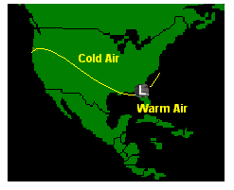
Generally speaking, if the cyclone stays just offshore, the results are much more devastating than if the cyclone meanders up the coast on an inland track. The Nor'easters that stay inland are generally weaker and only cause strong wind and rain. The ones that stay offshore can bring heavy snow, blizzards, ice, strong winds, high waves, and severe beach erosion. Remember, in these storms, the warmer air is aloft. Precipitation falling from this warm air moves into the colder air at the surface, causing crippling sleet or freezing rain.

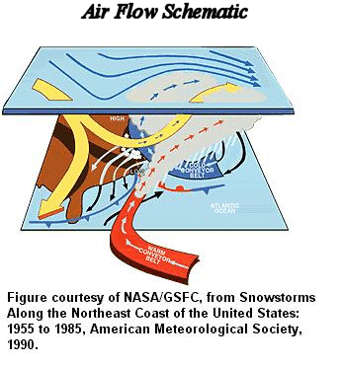

It is thought by many that the Arctic Oscillation, a band of air circulating at about 55N, may be responsible for the frequency of Nor’easters. The Arctic Oscillation has two phases: positive and negative. In the positive phase, which has been the predominant phase for the past twenty years, the air moves quickly and acts almost like a dam in preventing the intrusion of Arctic air into the mid-latitude regions. In its negative phase, the air moves more slowly and is more subject to disruption. This allows cold Arctic air to penetrate into the mid-latitudes. There can be a fluxuation between positive phase and negative phase days over the course of a winter, and a correlation between negative phase days and Nor’easters has been found.

There is a phenomenon that occurs within Nor'easters that can turn them from simple extratropical storms into what is known as a “bomb”. These bombs are characterized by a pressure drop of at least 24 millibars within 24 hours (similar to a rapidly-intensifying hurricane). Even though bombs occasionally share some characteristics with hurricanes, the two storms also have several differences. Bombs (being a type of Nor’easter) are extratropical, and therefore are associated with fronts, higher latitudes, and cold cores. They require strong upper-level winds, which would destroy a hurricane.

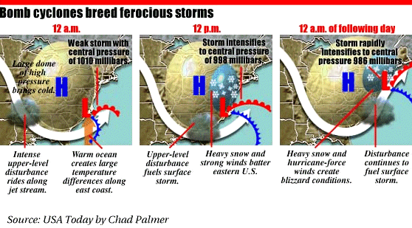

Though the occurrence of a Nor'easter can be forecasted with some accuracy, predicting their impact can be a little more complex. In 1993, researchers Robert Davis and Robert Dolan created a Nor'easter intensity scale, but it deals primarily with beach and coastal deterioration.

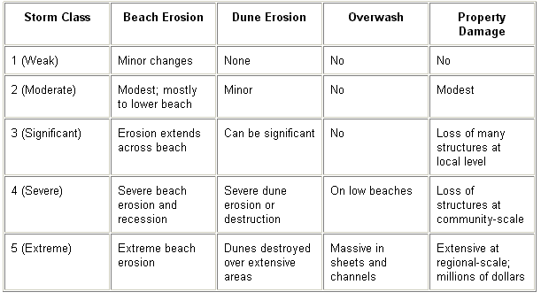

Gregory Zielinski, Maine’s state climatologist and an associate research professor at the University of Maine Institute for Quaternary and Climate Studies, has developed a Nor'easter intensity scale that deals more with the impact of the winter weather events associated with Nor'easters. He uses this scale in application not only to Nor'easters, but also for the Great Lakes Storms, like the one that sank the Edmund Fitzgerald. In an article posted in the January 2002 issue of the Bulletin of the American Meteorological Society (BAMS), Dr. Zielinski explains:

"My classification scheme allows forecasters and meteorologists to easily summarize the intensity of a winter storm by giving it an intensity index and placing it into its appropriate category on a 1-5 scale. The potential impact of the storm can then be passed on to public service officials so they may make plans for precipitation amounts, particularly snow, snowfall rates, wind speeds, drifting potential and overall impact on schools, businesses, travelers, and coastal communities."

In Zielinski's classification system, a second number reflecting forward speed is used together with the first number that is based on intensity. The second number also ranges between 1 and 5. A 5 would be the slowest moving and thus longest duration storm. A storm's category might be 2.4 or 4.3, reflecting intensity with the first digit and duration with the second.

One of the most publicized Nor'easters is the Halloween storm of 1991, or the "Perfect Storm" of movie fame. An extratropical cyclone formed along a cold front off the northeast U.S. coast. As it drifted toward Nova Scotia, the strong jet above deepened the Low pressure, and drew the remnants of Hurricane Grace into it, quickly robbing her moisture and dissipating her. Couple this with a high-pressure system that developed inland, and pressure gradient winds of incredible strength were created.

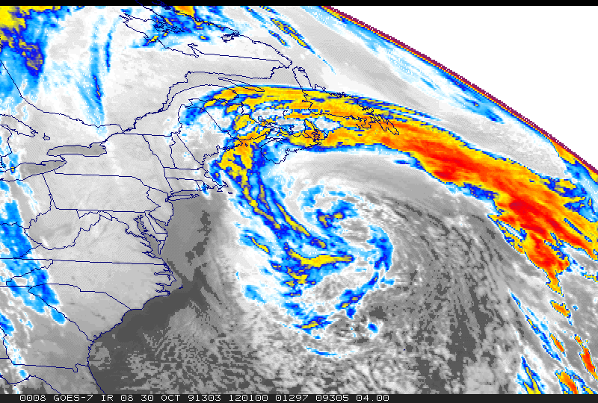
Infrared image of the Halloween Storm at its peak intensity. The Halloween Storm of 1991 was at different times: subtropical, tropical, and eventually spawned an unnamed hurricane in its remnants.

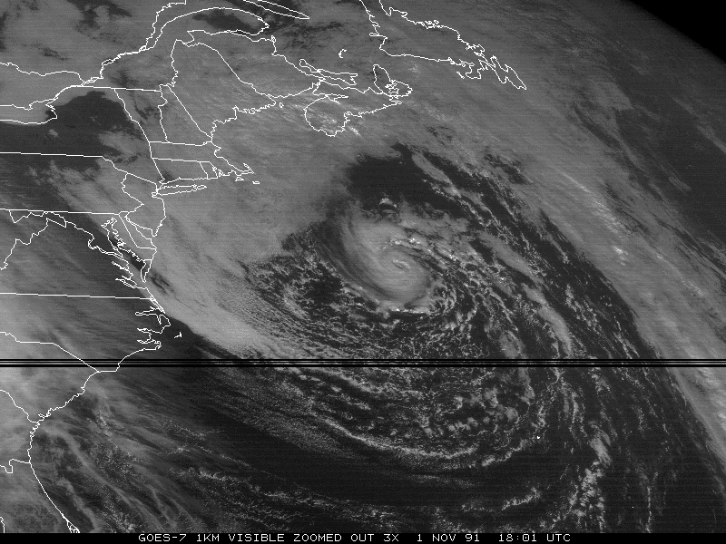
Visible image of the remnants of the unnamed hurricane, which started as an extratropical Nor’easter that turned into a Tropical Storm, and then a hurricane. NOAA decided to keep it unnamed to avoid confusion with Emergency Management agencies, as it occurred in the aftermath of such a destructive subtropical system. Note the difference in size from the subtropical storm it once was.

Speaking of American coastal weather, one can say that there may be landfalling hurricanes, but one can say with certainty that there WILL be Nor’easters. As mentioned, the damage from these great mid-latitude storms can be devastating. In addition to wind, flooding damage, and beach erosion, the bitter cold weather coming in after these storms pass is by far the biggest killer. Some places have lost power for weeks due to the ravages of a Nor’easter. Loss of power means loss of heat. Copious amounts of snow and ice leave people not only without power, but also without means to get to safety.
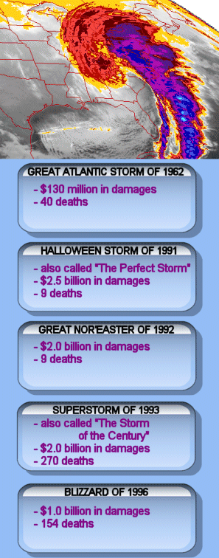

WINTER STORM SAFETY

Winter storms are killers. They leave people stranded: in their homes, in their cars, on highways, outdoors. We cannot eliminate the risks of severe winter weather, but we can take steps to minimize them. Weather awareness is always a key point in weather safety. Stay aware of developing conditions in your area and plan accordingly. Have a family disaster plan in effect, and discuss and rehearse it with your family. Such a plan may involve instructing children in what do if they are stranded home alone, or if they’re stranded at a friend’s house. Familiarize your family with the following preparation tips and survival guides.

Home Preparation

Here are a few ideas of things you can do around the house to prepare for winter storms:
* Purchase a battery-powered NOAA weather radio. Use it.
* If you have a woodstove or a fireplace, stack one week’s supply of firewood near a door, and cover with a plastic tarp.
* Have your fireplace flue cleaned and checked.
* Have your woodstove pipe connectors checked for leaks.
* Have your furnace cleaned and checked.
* Fill a garbage can with a sand/salt mixture and keep it in a spot close to where you are most likely going to need it.
* Check windows and doors for drafts and leaks. Update weather stripping.
* Make sure all gutters are clean and clear. Clogged gutters mean icicles.
* Have a good supply of nourishing food that doesn’t need to be thawed, heated, or cooked.
* Mark any obstructions near your driveway. Snowplows and emergency services vehicles have been known to get stuck on stone walls, rock gardens, boulders, etc.
* Check, test, and refresh batteries in all smoke and fire detectors.
* Have a flashlight and extra batteries for each person in the household, stored in an easily accessed site.
* After reading this article, go directly to your nearest hardware store and purchase carbon monoxide detectors. Install them immediately. Yes, they are THAT important.

If you’re stranded at home:

* In the event of a loss of power, confine people to one room.
* Layer clothing and blankets.
* Do not use charcoal as a heat source indoors.
* Drink and eat. Dehydration is a danger, and the digestive process generates heat.
* Prevent heat loss by covering windows at night and by sealing the room (towels under doors) as well as possible.
* Use candles when you’re awake, but extinguish them when you sleep.
* If you have the opportunity, prior to losing power, fill the bathtub with water. You can use this water to fill
the toilet reserve tank should the power later fail, and your water pump is incapable of filling the
reserve tank for flushing.

MESO has, in previous publications, posted a very carefully thought-out disaster kit for people to keep in their homes for all disasters. It is a list of things you would need should you be confined to shelter for any period of time, and certainly it would apply in a severe winter weather event.

* A first aid kit
* Blankets
* Bottled water (replace every 6 months or so)
* Canned goods (and a non-electric can opener) and nonperishable foodstuffs
* A few flashlights... and remember to periodically check those batteries
* A battery operated radio
* Prescription medications (check with your doctor or pharmacist on shelf life)
* Emergency cash
* A list of important phone numbers and emergency contacts
* Flares
* Matches in a zip lock bag
* Eyeglasses... possibly a good use for the "old ones" you just replaced.
* A change of clothes for each family member
* A box of handiwipes
* A porta-potty... or even a bucket.
* Additional batteries for whatever you use that requires batteries: hearing aids, radios, wheelchairs, flashlights, cell phones, etc.
*A fire extinguisher

Vehicle Preparation

Don’t drive when severe winter weather threatens if you can avoid it. If it cannot be avoided, make sure people know where you’re going, what route you are taking, and when you expect to get there. Call when you get there. In preparation, here are a few winter driving tips:

* Have your car completely winterized.
* Do any repairs you’ve been putting off.
* Check your tires, and make sure they’re all well treaded and have proper pressure… including the spare!
* That chip in your windshield will spread in the cold weather. Fix it.
* Don’t over-drive your abilities, the road conditions, or your car’s capabilities. Drive no faster than the speed at which you want to hit a tree at.
* Don’t assume that 4-wheel drive makes you immortal. In ice, there is no traction, regardless of how many wheels are getting power.
* Take a defensive driving course. In addition to possibly saving your life, your insurance rates will be lowered.
* Keep the gas tank full.
* Remember, that in cars WITH antilock brakes, when braking you must maintain a firm consistent pressure
when stopping. Cars WITHOUT antilock brakes require that you pump the brakes when stopping on limited traction surfaces.
* Brake or reduce speed prior to approaching a curve, when your wheels are straight.
* Brake or reduce speed prior to cresting a hill, and use low gear to descend.
* In an emergency, sometimes it is possible to scale a slippery hill by putting your passenger side wheels on
the grass or shoulder of the road, where there may be more traction.

A car winter survival kit should contain:

* A shovel
* Sand or kitty litter
* Blankets
* Jumper cables
* A flashlight and extra batteries
* Matches in a zip lock bag
* Snacks
* Flares
* A snowbrush with ice scraper
* A change of clothes, including socks and shoes
* A tool kit with a utility knife
* Bottled water

If you’re stranded in a vehicle:

* Put as many layers over yourself as possible; even newspapers can insulate you.
* Again, drink and eat if possible. Don’t eat snow. It will lower your body core temperature.
* Get out and check that the exhaust pipe is clear. If snow piles up to it while the car is off, the next time you turn it on the car will fill with carbon monoxide.
* Run the car and the heater often enough to keep you alive, not toasty. You don’t know how long you’ll be there. A few minutes every hour is enough. Crack the window to avoid asphyxiation.
* Do whatever you can to make your car visible to rescuers. Leave the lights on and honk your horn periodically when the car is running. Attach a brightly colored piece of cloth to your antenna.
* Keep moving. Flex fingers and toes, exercise.

If you’re stranded outdoors:

Most winter days are clear and sunny. Use them for things like hiking, road trips, etc. The days that threaten to be snowy or stormy are best spent with home-based activities. More than any other season of the year, plan around the weather. However, if you do find yourself trapped outdoors in winter weather, these tips may be helpful…

* Seek shelter. If you can’t find shelter from the cold, at least find shelter from the wind.
* Try to mark the spot you are sheltering in so that rescuers can find it.
* Try to build a small fire.
* Melt snow to drink, don’t consume snow. Snow consumption lowers your body core temperature, hastening hypothermia.
* Stay put, if you’re in a relatively safe place. Don’t try to walk to safety unless it’s within sight.
* If you’re with others, stay together. Huddle to conserve body heat.

MESO, October 2002

http://www.mcwar.org

